Predictive Analysis Tool System Design Specification
Author | Revision Number | Date
architect | 1.0 | 1 August 2012

Predictive Analysis Tool System Design Specification 1
System Design Specification 3
1. Introduction 3
1.1 Purpose 3
1.2 Glossary 3
2. Logical Architecture 4
2.1 Prediction Analysis Tool Front End 4
2.2 Prediction Analysis Tool Back End 4
2.3 Prediction Analysis Tool Core 4
3. Modular Architecture 4
4. Data Model 5
5. Process Architecture 6
5.1 4.4.1 Login [external], 4.4.2 Logout [external], 4.4.32 Perform authorization 6
5.2 4.4.3 View homepage 6
5.3 4.4.4 Get help 6
5.4 4.4.6 Access predictions history information 6
5.5 4.4.7 Change prediction time 6
5.6 4.4.9 Import analysis data 6
5.7 4.4.11 Test what-if case 6
5.8 4.4.12 Manage what-if scenarios 7
5.9 4.4.14 Run prediction algorithms on the provided input data, 4.4.28 Execute prediction algorithm 7
5.10 4.4.15 Select prediction results 7
5.11 4.4.17 Generate report, 4.4.22 Generate reports 7
5.12 4.4.18 Export report 7
5.13 4.4.24 Read backlog information 7
5.14 4.4.27 Evaluate risk factors 7
5.15 4.4.29 Write predicted scenario information to the database 8
5.16 4.4.30 Perform currency conversions 8
5.17 4.4.31 Localize GUI pages 8
5.18 4.4.33 Perform Logging 8
5.19 4.4.34 Perform Auditing 8
6. Security 8
6.1 Authentication 8
6.2 Authorization 8
6.3 Audit 8
6.4 Data Privacy 8
6.5 Data Integrity 8
7. Deployment and Development Concerns 8
7.1 Logical Deployment 8
7.2 Physical Deployment 9
7.2.1 Hardware 9
7.2.2 Software 9
7.2.3 Database 9
7.2.4 Application Server 9
7.2.5 Operation Systems 9
7.2.6 Technical Overview 9
7.3 User Interface Implementation 9
7.4 Concurrency and Transaction Management 9
7.5 Configuration 10
7.6 Logging 10

System Design Specification

Introduction

Purpose
This project will implement a new application which is based on the current contract backlog and sales volumes data collected for each platform. The application will be able to predict the impact of some parameter changes. Such parameter changes could be for example, warranty exit capture rates, warranty upgrade rates and so on.

The results of the predictions will give an accurate estimate of the evaluated impact and will allow the users or other applications to adjust in consequence, thus being able to make more informed business decisions.

Glossary
Acronym/Term | Description
MVC | Model View Controller
API | Application Programming Interface.
PDF | Portable Document Format
XML | Extensible Markup Language
URL | Universal resource locator
HTML | Hypertext Markup Language
JSP | Java Server Pages
Rollup | As per client: Let's say you are rolling up sales dollars from each country. country A $1,000,000 sales and country B has $1,000 sales. so if we wanted to project sales growth, a $500 sales increase for country B would be 50% increase projection. country A only grows at 5%. if you average 50% and 5% and you get overall growth at 27.5%. which isn't correct. you need some logic to account for relative size of the country.

Logical Architecture

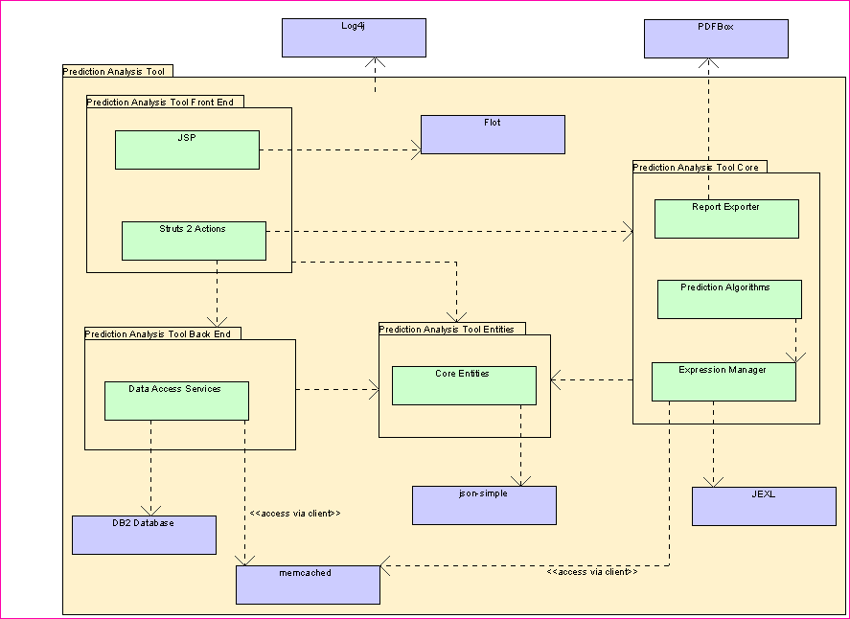

Prediction Analysis Tool Front End
This layer is application’s front-end. These will be used to develop the UI of the application. It contains the JSP, JavaScript for chart display and the Struts actions.

Prediction Analysis Tool Back End
This layer consists of all database access for the application. This will include services to load the input data, retrieve lookup data and save algorithm input and output.
Any future service methods that need to access the database need to be added to this layer.
It also consists of the interfaces for the prediction algorithm, expression parsers and report exporters. All future interfaces which do not deal with front-end need to be added to this layer.
This layer also includes the entities.

Modular Architecture
Two modules are spawned.

Prediction Analysis Tool Back End Module - This module will be responsible for all entities and services in main class diagram.

Prediction Analysis Tool Front End And Miscellaneous Module - This contest will be responsible for the front-end including the JSP, JavaScript and Front-End actions (both for the Admin and General site). It will also be responsible for the Flot graphs.

Data Model
This section describes the entities defined in the system.

The terms Fact and Dimension are borrowed from data warehousing as they are applicable here. A fact is usually a numeric value which is the point of concern. The dimensions are the metric with respect to which the fact is defined. The dimension is something by which we usually aggregate the facts.
We take a simple example of the company which sells a product. There are the terms Sales, Revenue, Year, City, Country and Continent. Here Sales and Revenue are facts and Year, City, Country and Continent are dimensions.
The FactType and DimensionType are used to model the types of facts and dimensions available. In the above example, there are 2 FactTypes available (Sales and Revenue) and 4 DimensionTypes available (Year, City, Country and Continent)
The InputValueType is a general type which acts as input. Currently we have two types of input values and thus FactType and DimensionType derive from it.
The InputValue is an actual value for an input. For example, a Revenue of $2000 consists of the FactType = Revenue and value = 2000.

FactData is a model for a table of input data.
The factTypes and dimensionTypes are the columns for the table (in the given order). The total number of columns is factTypes.Length + dimensionTypes.Length
The tabularData contains the actual data. Here the outer list acts as the row and inner list acts as the column and InputValue acts as the cell value. The following table of data can be easily modeled using a FactData.
Sales | Revenue | Year | City | Country | Contnent
20 | 2000 | 2011 | Chicago | USA | North America
30 | 3900 | 2012 | Chicago | USA | North America
20 | 2500 | 2011 | LA | USA | North America

The underlying data for InputValue is a byte array and hence various methods are provided for getting the data in various formats (such as long, int, string, double etc.). This functionality is equivalent to the Java ResultSet

EstimatedValueType is used to model those input values which are estimations and are not fixed. The EstimatedValue models a value of such a type.

InitialSettingType is used to model those input values which are initial settings for an algorithm. The InitialSetting models a value of such a type. For example in the wireframe, these values are the prediction dates, rollup selection etc.
The input for an algorithm is an instance of the AlgorithmInput class. It consists of the initial setting values, the estimation values and the fact data. It is used to denote both an original input and a what-if case. In the what-if case, the AlgorithmInput.isWhatIfCase = true and AlgorithmInput.parentId is equal to the original algorithmInput.id.

The OutputValueType is a type for an output value. For example, “Year-To-Year Growth”, ‘Yearly NEW Revenue” etc. The OutputValue is the actual value of such a type, say $2000.
The OutputValueType class also exposes two static methods which will convert the value of an OutputValue (of the given OutputValueType) into a JSON fragment or an XML node. The former is useful for making the data useful for JavaScript and Flot graphs. The latter is useful for exporting to xml which can be used for various arbitrary purposes.
The AlgorithmOutputTable is a table of output values. It is quite similar to FactData (which is instead for input)
The AlgorithmOutput is simply a bunch of output tables which have a key name.

The AlgorithmType encapsulates different algorithms that are used for the same purpose. The name of the algorithm must be unique globally.
To take an example from cryptography, MD5 and SHA1 are used for the same purpose “Hashing”. Here the names are “MD5” and “SHA1” and the algorithm type is “Hashing”

The PageRequest and PageResult<T> are merely DTOs used for paging on front-end.

Process Architecture

4.4.1 Login [external], 4.4.2 Logout [external], 4.4.32 Perform authorization
This will be done by the front-end module. Integration with IBM Bluegroups SSO is required. IBM Bluegroups also contains both the user and the user role information.

4.4.3 View homepage
Currently it is not highly clear what the home page will consist. If the last-run predictions need to be displayed, we can use the AlgorithmInputService and AlgorithmOutputService’s getAll and search methods. The timestamp field can be used for sorting in order to get the latest results. The user field can be used to get the results belonging to a particular user. The algorithName can be used to find the results for a particular algorithm.
The homepage also shows a list of all prediction algorithms which can be obtained using DataAccessService.getAllAlgorithms

4.4.4 Get help
It is assumed this help contain static content.

4.4.6 Access predictions history information
The prediction outputs can be retrieved using the AlgorithmOutputService’s get, getAll and search methods.

4.4.7 Change prediction time
The “prediction time” (or start and end times) should be defined as an InitialSettingType. The actual value of the “prediction time” is modeled by an InitialValue with the given InitialSettingType.

4.4.9 Import analysis data
Not implemented as it is optional.

4.4.11 Test what-if case
A what-if case is nothing but a different input for the same algorithm. However the AlgorithmInput.data (fact data) does not change (as it is fixed). The AlgorithmInput’s estimated values and initial settings can be changed and the PredictionAlgorithm.runAlgorithm method is run again.

4.4.12 Manage what-if scenarios
The What-If scenario (AlgorithmInput) can be saved using the AlgorithmInputService’s create or update methods. The AlgorithmInput.friendlyName can be used to save it with a user-given name.

4.4.14 Run prediction algorithms on the provided input data, 4.4.28 Execute prediction algorithm
The PredictionAlgorithm.runAlgorithm method is used to run an algorithm.

4.4.15 Select prediction results
The output of PredictionAlgorithm.runAlgorithm call is AlgorithmOutput. It contains one or more tables containing the output data. One or more of these tables can be selected for further use such as exporting or plotting.

4.4.17 Generate report, 4.4.22 Generate reports
Each of AlgorithmOutput.data is an instance of AlgorithmOutputTable. The AlgorithmOutputTable contains a toJSON method which will convert the tabular data into JSON. This JSON can then be used by the front-end controllers to bind to the Flot graphs.
The types of graphs required are quite common and are already supported out of the box.
Bar Charts - http://people.iola.dk/olau/flot/examples/graph-types.html
Stacked Charts – http://people.iola.dk/olau/flot/examples/stacking.html
Waterfall Charts - http://www.jumware.com/Includes/jquery/Flot/Examples/waterfall.html

4.4.18 Export report
The ReportExporter has been designed for exporting reports. It takes in the algorithm output and returns a byte array of the exported report.
The current requirement suggests PDF, CSV and XML reports. Each particular format should have a dedicated interface deriving from the ReportExporter interface.
The PDF exporter should use PDFBox library
The CSV exporter can simply use Java code for building CSV.
The XML exporter can use the AlgorithmOutputTable.toXml() which will return an XML node. It can then use an XSL transform to change the structure of the XML (if needed).

4.4.24 Read backlog information
The reading of the information from the database will be done using the DataAccessService’s getDataForAlgorithm and getFactData methods.
The getDataForAlgorithm will get the data from the database, generate an id for it and optionally cache it.
The getFactData will take an id and find the data in the cache. Only if it does not exist in cache, it will run the queries and get the data from database.

4.4.27 Evaluate risk factors
Out of scope

4.4.29 Write predicted scenario information to the database
The AlgorithmOutputService’s save and update methods are used to store either the full or partial algorithm output to database.

4.4.30 Perform currency conversions
This will be part of the algorithm logic. The data will probably come from a live web service rather than the database. The CurrencyService.getConvertedCurrencyValue will be used for this.

4.4.31 Localize GUI pages
The front-end module architect is responsible for the localization requirement. The locale preference must be read from the browser preference (if exists) otherwise English is used.

4.4.33 Perform Logging
Log4J will be used both at front-end and back-end for performing logging.

4.4.34 Perform Auditing
This is not needed.

Security

Authentication
Authentication will be done by integrating with IBM Bluegroups SSO. IBM Bluegroups contains both the user and the user role information.

Authorization
Authorization will be done by integrating with IBM Bluegroups SSO. IBM Bluegroups contains both the user and the user role information.

Audit
NA

Data Privacy
Besides the authentication and authorization, SSL should be used to transfer all the sensitive data.

Data Integrity
Data Integrity will be maintained with the help of foreign keys in the database.
Multiple database writes which belong to the same logical operation will be performed in a single database transaction. This will maintain the consistency of data in the database.

Deployment and Development Concerns

Logical Deployment
Standard Struts2 based web application deployment will be used. The application will be compiled into a war file. This page demonstrates the deployment of a war onto WebSpehere Application Server.
Initially the services will be used as POJO services as the required number of users does not seem too large to warrant a separation of front-end and back-end servers.
Initially, memcached will also be deployed on the same server in the single server mode. Later on we can move to a clustered setup mode if required.

Physical Deployment

Hardware
- Unknown

Software
- J2SE 1.5
- J2EE 1.5

Database
- DB2 11.x

Application Server
- WebSphere Application Server 7.x

Operation Systems
- Solaris

Technical Overview
- Struts 2.2 – It is used as the front-end framework.
- jQuery 1.7.2 – It is used as the JavaScript framework
- Flot 0.7 - It is used for providing charts using the javaScript.
- memcached 1.4.14 – Provides a caching persistence.
- spymemcached 2.8.2 – Java memcached client
- JEXL 2.1.1 – Used for parsing and evaluating expressions. These expressions will be used by the algorithm
- json-simple 1.1.1 – For conversion of objects to and from JSON
- log4j 1.2.9 – Provides logging
- PDFBox 1.7.1 – Note that this is an older version. It is LGPL instead of the current AGPL

User Interface Implementation
JavaScript with jQuery, flot graphing library, JSP and Struts actions will be used to implement the front-end.

Concurrency and Transaction Management
The back-end will be responsible for starting, committing and rolling back transactions.
Simple JDBC transactions must be used.

Configuration
Struts configuration is done in the struts.xml file.
The module architects can decide the API to use for configuration. Simple properties file or xml file based configuration is expected. If more complex libraries are needed for configuration, it must be confirmed in forum.

Logging
Both front-end and back-end will use log4j for logging.

Thread Safety
The front-end controller need not worry about thread safety as they are always called from the same thread.
The back end services must be thread-safe as they will be called from multiple threads.

Exception Handling
The back-end module architect will define a base exception called PredictiveToolAnalysisException. Further exceptions can be defined which derive from this exception.
The front-end controllers will catch the exceptions from back-end and show appropriate error page. The front-end architect must define custom exceptions for the PredictionAlgorithm and the ReportExporter interfaces.

